1.Introduction :

1.1 Overview

The implementation phase involves putting the project plan into action. It’s here that the project manager will coordinate and direct project resources to meet the objectives of the project plan. As the project unfolds, it’s the project manager’s job to direct and manage each activity, every step of the way. That’s what happens in the implementation phase of the project life cycle: you follow the plan you’ve put together and handle any problems that come up.

The implementation phase is where you and your project team actually do the project work to produce the deliverables. The word “deliverable” means anything your project delivers. The deliverables for your project include all of the products or services that you and your team are performing for the client, customer, or sponsor, including all the project management documents that you put together.

1.2 Purpose:

A CRM can help you store customer data such as user behavior, how long a customer has been with your business, purchase records, and notes on sales interactions, which you can use to optimize your sales and marketing processes and improve customer service across your organization

2.Problem Definition & Design Thinking

2.1 Empathy Map

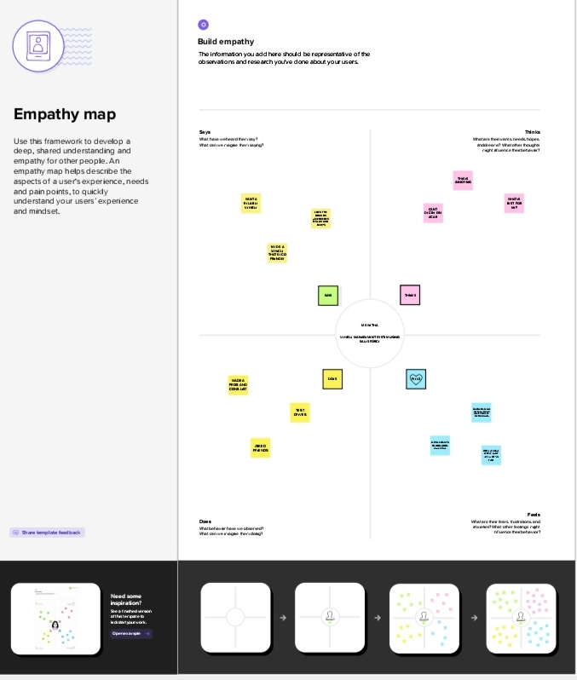

2.2 Ideation &Brainstorming Map

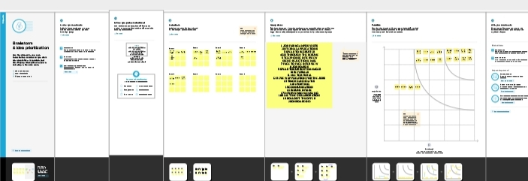

Result

Data model:

|  |  |
| --- | --- |
| Object Name | Field in the object |
| Obj 1 | |  |  | | --- | --- | | Field Label | Data Type | | Candidates  Name | Text | |
| Obj 2 | |  |  | | --- | --- | | Field Label | Date Type | | Owner | Lookup | |

3.2 Activity & Screenshot :

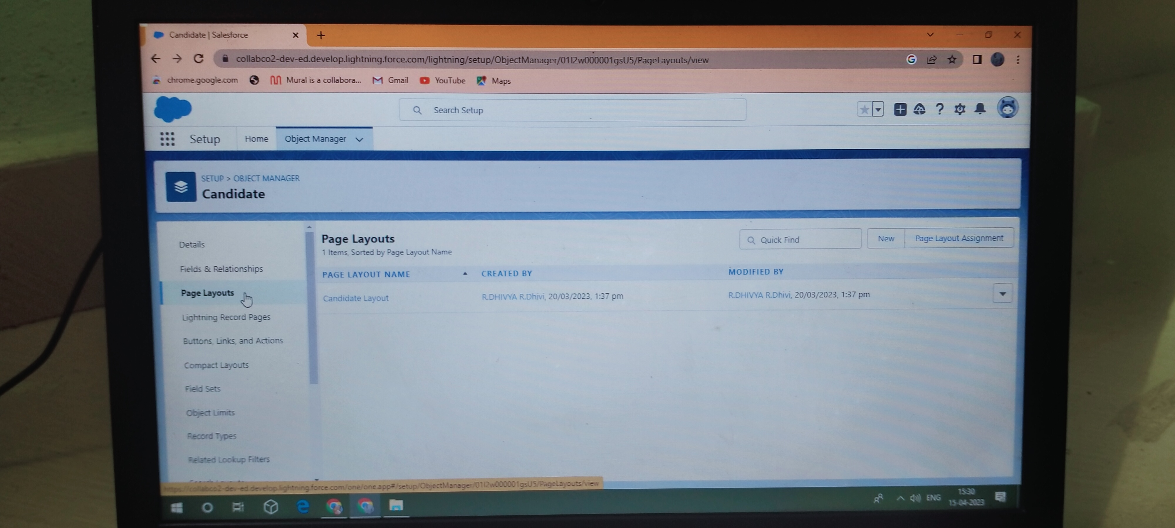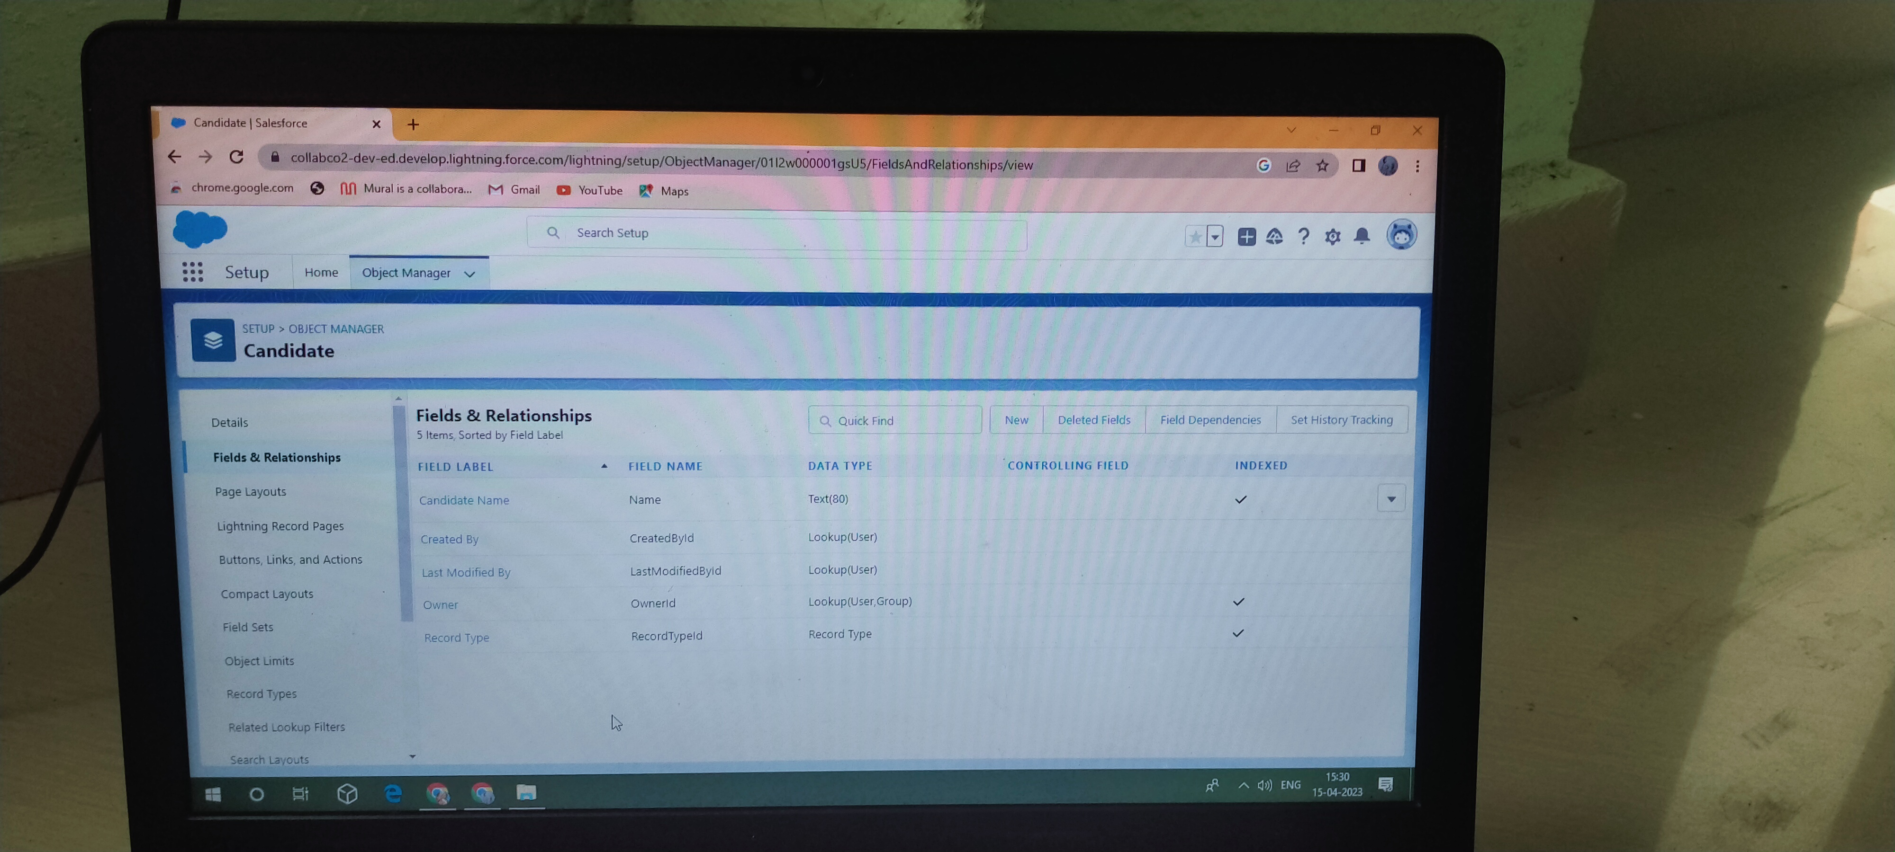

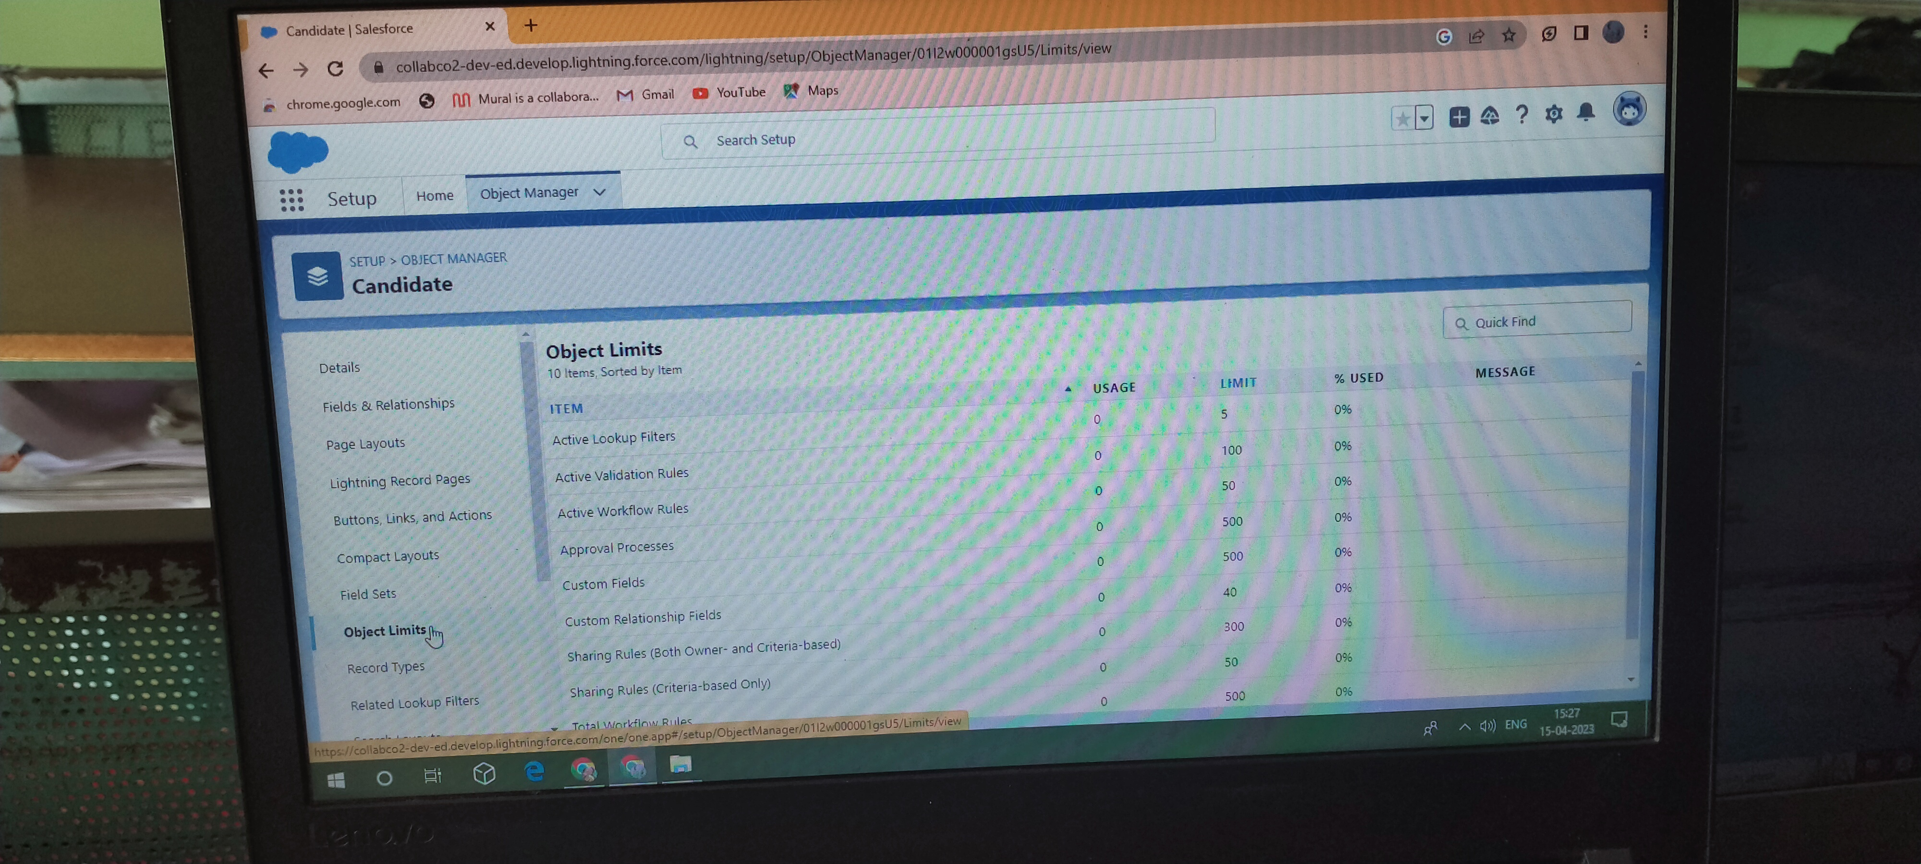

Trailhead Profile Public URL:

Team leader -https://trailblazer.me/id/dhivr6

Team Member 1-https://trailblazer.me/id/divya1212

Team Member 2 -https://trailblazer.me/id/gopiga33

Team Member 3 -https://trailblazer.me/id/iswak1

Advantages and Disadvantage:

Collecting and organizing actionable customer data is a full-time job, and one that isn’t very forgiving of mistakes. As such, investing in a high-quality Customer Relationship Management (CRM) tool is a must for any business that wants to take customer satisfaction to the next level. CRM offers a number of advantagesthat will help you identify, understand, and assist your clients, so that you’ll never have to worry about losing revenue as a result of incomplete data. Here are six benefits of CRM software that can help your company find success.

Before we get into the CRM benefits for business from your side as CRM users, whether as a business owner or salespeople team leader, let's talk about how your customers will benefit from you using a customer relationship management system. Some of the key customer relationship management benefits for customers are the following:

Disadvantage:

We’ve looked at the pros—the advantages—of initiating a CRM system, so now it’s time to examine some of the cons—the disadvantages—of a CRM system. Whilst ultimately these are fewer in number than the advantages, for some businesses, the short-term pain of a cultural and technological shift can be a lot to bear and may not generate a return Staff over-reliance on CRM may diminish customer loyalty through a bad experience.

If staff come to rely too heavily on CRM software, it reduces their flexibility in dealing with customer queries. They often become helpless in the face of questions from clients where the information isn’t on the system and which requires lateral thinking to solve the problem. This has obvious implications for the customer experience and clients may become frustrated, taking their business to a competitor.

Application:

Today we announced that Radancy has acquired Ascendify, adding value to our Radancy Talent Acquisition Cloud through advanced candidate relationship management (CRM) capabilities. This acquisition enhancessuitesolutions focused on helping enterprises maximize ROI, reduce costs and find qualified talent to strengthen their business.

Traditionally, talent technology has consisted of siloed solutions, often involving manual processes. With the Radancy Talent Acquisition Cloud, we offer a single, integrated, end-to-end platform that automates and optimizes the candidate recruitment process – allowing our platform to deliver more effective and cost-efficient outcomes.Now with Ascendify and their team, we add valuable CRM-based recruiter tools and years of expertise to further enhance our platform. New features include advanced sourcing functionality, workflow automation, interview scheduling and event management to augment our industry-leading platform and candidate marketing capabilities.As the need for quality talent continues, companies are increasingly seeking data-driven tech solutions to find talent more effectively. I am proud that Radancy meets that demand with the only all-in-one platform. We enable companies to maximize their reach, optimize touchpoints and increase efficiency.

Conclusion:

Customer Relationship Management enables a company to align its strategy with the needs of the customer in order to best meet those needs and thus ensure long-term customer loyalty.ConclusionCustomer Relationship management is a business strategy that enables a business organization tomaximize revenue, customer satisfaction, profitability through strategic mobilization, organization, and management of customer’s interests and desires. BWM has traversed numerousbusiness challenges that made it establish a CRM that will foster customer relationship as a baseline for market strengthening and diversification. BMW has diversified its market in various global markets through the initiation of the CRM systems. The system has significantly contributed to the company’s financial, operational, managerial and development initiatives with a robust customer relationship that has fostered great sale of its product.Mercedes Benz operates a similar customer relationship management system just BMW and due to market power, the company has greatly diversified is customer roots to various market bases. Mercedes has majored in a customer-dealership business relationship. This has provided the company with strategic mechanization of customer retention, satisfaction and purchase behavior enhancing the company’s profitability through an increased purchase command. The two companies are among the leading CRM implementers in the automotive

Future schop:

The future of CRM will witness an increase in the use of CRM as a single source of truth because it will connect everything under the sun, from employees, departments and teams to stakeholders. In the coming years, CRM will become a technology not just used by customer-facing teams but by the entire organization

CRM systems might imply automation, but many only offer baseline automation options. The future of CRM will include users who demand more functionality. They'll be looking for providers that cover typical CRM essentials as well as more sophisticated automation

Scope” refers to how far-reaching the CRM will be within your organization. For example, if only yourcustomer service reps will be using it, the scope of your CRM would be considered narrow.